D2L (Desire2Learn)

Basics

Created for Adult Basic Education use. Contact Adult Basic Education Coordinator Cambridge-Isanti School District #911 625 Main Street North Cambridge, MN 55008. Phone: (763) 689-6228 Fax: (763) 689-6239 E-mail: vicki_ostrom@cambridge.k12.mn.us

Table of Contents

What is D2L? 2

My Home 4

Course Home 6

Navbar Types 7

General Navbar 7

Course Navbar 8

My Preferences 9

General Settings 10

Discussion room settings 11

Pager 13

Content 14

Utilizing the Topic Toolbar 15

Discussion 17

Classlist 20

Dropbox 21

Quizzes 22

Grades 23

Chat 24

Glossary 25

# What is D2L?

D2L is short for Desire to learn, an online course management system (CMS) used by many colleges and universities. Think of it as a website for your class. A D2L course site allows "anytime, anywhere" access to syllabi (course outlines), readings, multi-media files, electronic dropboxes (places to turn in assignments), online quizzes, email, grading, student progress reports, project files, etc.

The best way to get started with D2L is to try it. Mankato State University has a demonstration course about online learning set up in D2L at <http://www.mnsu.edu/ext/online/demo.html>

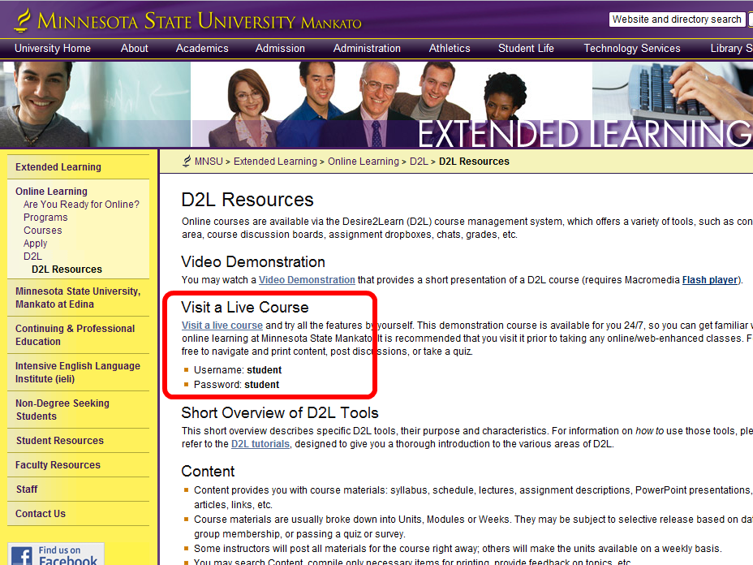

Click on the **Visit a live course** link to go to <https://d2l.mnsu.edu/>

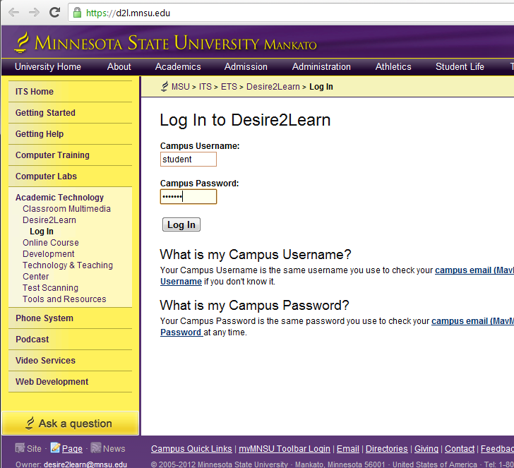

To log in to the live demo of D2L, enter ‘student’ in both the **Campus Username** field and in the **Campus password**

**TIP: Log In**

You can click the Log In button after entering your username and password, or just hit Enter on your keyboard.

The first page displayed after you log in to D2L is **MyHome**

# My Home

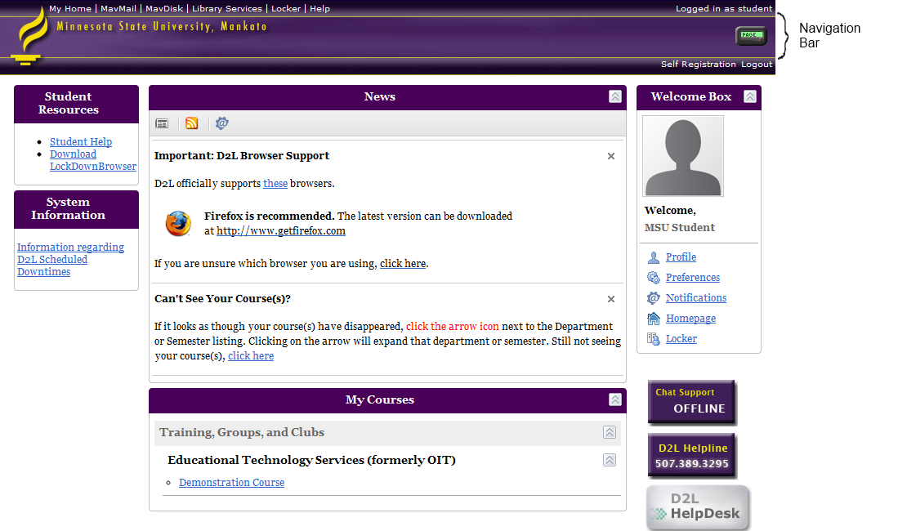

|  |  |  |
| --- | --- | --- |
| Top Navigation Bar: |  | The top navigation bar usually contains the D2L banner, the Desire2Learn Navigation bar, and the Course Navigation bar. |
| News: |  | This area shows helpful announcements. |
| Course List: |  | The Course List shows the courses that you are enrolled in. |

Click on **Demonstration Course**

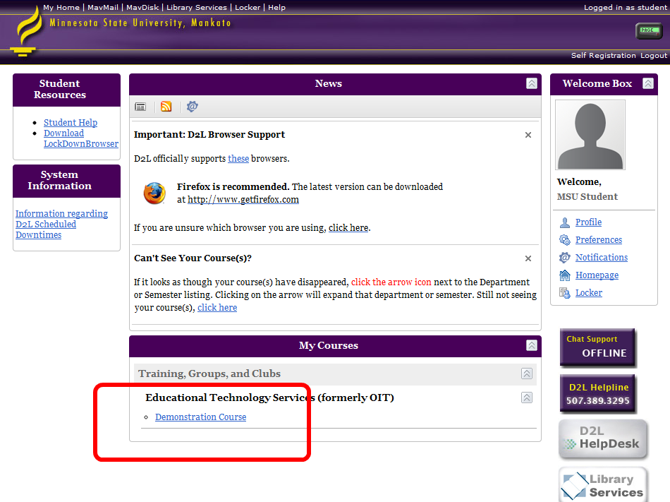

# Course Home

Then next page will be the **Course Home** page for the demonstration course.

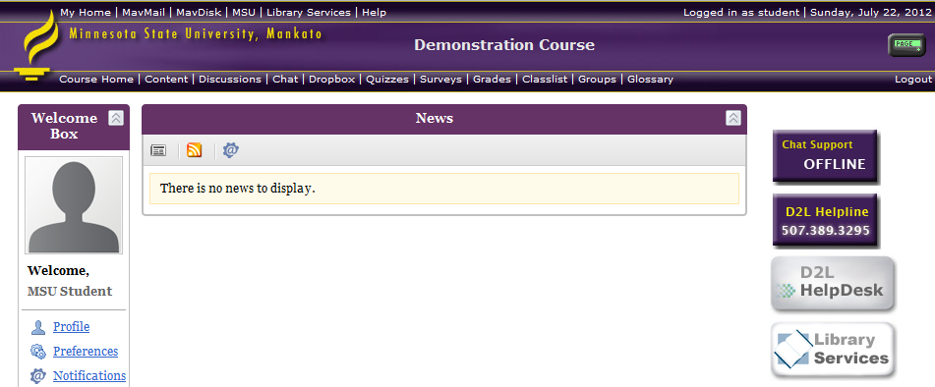

The instructor can post messages for the class here.

Click on Content in the Course NavBar to see the demonstration modules.

# Navbar Types

As soon as you login in to Desire2Learn you will be able to see the navigation bar on the top of the page as shown in picture below.

## General Navbar

The general navigation bar – or ‘navbar’ – is located on the topmost area of the page. It consists of general items My Home, MavMail, MavDisk, MSU, FAQ and Help. It is visible at all times and looks like top navigation bar.

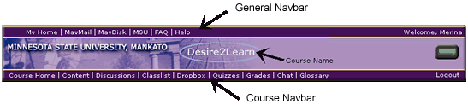

## Course Navbar

Once you enter a course, the navbar looks like Figure 1. The General Navbar at the top remains same, but the Navbar at the bottom is the Course Navigation bar as shown in Figure 1.

|  |  |
| --- | --- |
| Course Nav | Contains… |
| Course home | Front page of the course where the instructor can post news. |
| Content | Everything the instructor has posted about the course, including syllabus, lectures, etc. |
| Discussions | This is where you will read and respond to discussion topics. |
| Chat | This serves as an open forum for you to ask questions of your classmates. |
| Dropbox | This is where you upload files to submit assignments. |
| Quizzes | Your instructor will create quizzes here. They are often only available for a set amount of time. |
| Grades | Grades for quizzes should show up automatically. Other grades are posted by your instructor. |
| Surveys | Your instructor can create surveys here. |
| Classlist | This shows everyone enrolled in your course and gives you a quick way to contact them. |
| Groups | You may be assigned to a group for certain assignments. |
| Glossary | If you don’t know the meaning of a term related to D2L, check here. |

# My Preferences

**My Preferences** are groups of tools that allow you to change your font, password, preferences etc. Customizing your personal settings is a great way to ensure that you are comfortable in your new learning environment.

***Note:****These tools are available outside your courses. This means that changes you make here will be reflected in all of your courses.*

|  |  |
| --- | --- |
| In order to set up your preferences:   1. From **My Home**, in the ***Welcome Box***, click **My Preferences** link. 2. Then ***My Preferences*** screen appears. Here you will be shown a series of tabs as shown on Figure 1, click on the tabs to access different settings. | http://ets.mnsu.edu/d2l/tutorials/images/WelcomeBox.gif |

# General Settings

|  |
| --- |
| You can customize the general settings such as online status, or font style and size by changing the settings in My Preferences under the General tab.   1. From **My Home**, on the ***Welcome Box***, click **My Preference** link. 2. The General Settings is accessible under the **General** tab, which is shown by default 3. Under the Font Setting heading, use the drop-down menu to change the font **Face** and font **Size**. The **Preview** box will show you how the selected font will look. 4. Click **Save** button.   http://ets.mnsu.edu/d2l/tutorials/images/general.gif  ***Note:****The font affects only Desire2Learn fonts and does not affect the font face or size of the content set by the user.* |

# Discussion room settings

|  |
| --- |
| You can customize the discussion room set up by choosing the various options under My Preferences for the Discussion.   1. From **My Home**, on the ***Welcome Box***, click **My Preferences** link. Refer to Figure 1. 2. Discussion settings are accessible under the **Discussion** Tab. 3. Choose the various **Discussion Topics Frame** settings according to your preferences as listed below.    1. **Discussion Topic Frame**: Shows or Hides Discussion Topic frame on the left hand column.    2. **Search Bar**: Shows or hides the search bar above the discussion subject list.    3. **Search Bar Type**: Normal will display the search bar where you have simple search options. Advanced will display the search bar where you can search within the discussion forum by keyword, date posted, subject, name of individual.    4. **Topic List Type**: Choose Single forum to lists the topics of the single discussion forums and all other available discussion forum. 4. Use the drop-down menus to choose your default **View Type**.  **Threaded** will show only the original messages and its subsequent reply.  **Not threaded**will show both the original messages and the reply to the messages. You may choose the type of messages to display that are arranged either according to date, subject or name of person who posted. 5. Click **Save** button.   http://ets.mnsu.edu/d2l/tutorials/images/Discussion.gif |

# 

# Pager

|  |
| --- |
| Pager is a tool that can be used to inform you who is online and enables you to contact them. The pager allows students to pose questions to you on a one-to-one basis, removing some of the anxiety normally found in a traditional classroom setting.   1. From **My Home**, on the ***Welcome Box***, click **My Preference** link. 2. The pager settings are located under the **Pager** tab as shown in Figure 4. 3. Turn on/off your pager sounds by selecting the option beside **Pager Notifier**. 4. Choose the desired **Pager Sound** from the provided list if you choose to turn on the pager notifier. 5. Click **Save** button.   http://ets.mnsu.edu/d2l/tutorials/images/pager.gif ***Note:****When you are paged by someone the image at the upper right hand corner http://ets.mnsu.edu/d2l/tutorials/images/pager1.jpgflashes in green color and beeps if the pager notifier is turned on.* |

# Content

The ***Content***can be accessible from the course home page by clicking the **Content** link located on the Course Navbar. Materials for the course are posted in the content area.

http://ets.mnsu.edu/d2l/tutorials/images/Navbars_Content.gif

Accessing content:

1. Click the **Content** link. You will then be able to view the material (content matter) of the Course content.
2. The left hand side will display the ***Modules***, with the title of the lesson, chapter, topic or unit. Clicking on the title will let you view the full content of that topic.

Search Content:

1. Click **Content** on the Course Navbar
2. Click the http://ets.mnsu.edu/d2l/tutorials/images/Content_SearchContent.gif link located on the upper right corner of the page.
3. Type the keyword on the box beside the Search.
4. Click **Search** Button.

Selectively Print Content

1. Click **Content** located on the Course Navbar.
2. Click the http://ets.mnsu.edu/d2l/tutorials/images/Content_Compile.gif link located on the right area of the page.
3. Check the boxes besides the documents that you want to be printed.
4. Click on the **View**button to preview. A new window will popup with the content in the printable format.
5. If you are satisfied, you may print by choosing File>Print from the menu bar.

# Utilizing the Topic Toolbar

Topic toolbar can be accessed by clicking on the content, then opening the topic.

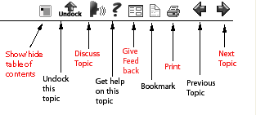

|  |  |
| --- | --- |
| Show/hide table of contents: | If you want the larger area for the content to be displayed you can hide the table of contents on the left side. You make it appear again by clicking the icon show/hide table of contents. |
| Undock this topic: | It will open the topic document in a new window. |
| Discuss topic: | It will show if the topic is related to discussion forum. |
| Give Feedback: | It will display the feedback window to rate the topic and add comments. Once you are done you may submit by clicking **Submit** button and click **Close Window**. |
| Bookmark: | It will mark the document to be retrieved for future purpose. The bookmarked document can be accessed through the link bookmarked on the course Home page. *Note: Instructors of the course must have this option turned on in order for the bookmarks to show up on the course Home page.* |
| Print: | It will send the current open document to print. |
| Previous Topic: | It will help to navigate the previous topic. |
| Next Topic: | It will help to navigate the next topic. |

# Discussion

Discussion allows you to communicate with your instructor and the peers without have to be online at the same time.

http://ets.mnsu.edu/d2l/tutorials/images/Navbars_discussion.gif

Posting Message on Discussion Board:

1. To post a message, go to the course home page and click the **Discussions** link on the course navbar. It will list the available discussion forums and topics.
2. Choose the topic under which you wish to post a message.
3. Click **Add Message** button as shown below. You should be able to view the area to type the message on the lower part of screen.
4. Type in the subject of the message in the box beside **Subject**.
5. Type the message in the bigger text box.
6. You may attach a file to the message, if you wish, in the Attach File box or by clicking Browse and choosing the file.
7. Click **Submit** button.

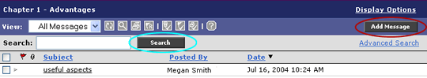

View message posted on Discussion Board

1. Click **Discussion** located on the Course navbar.
2. Click the Discussion topic title link that you wish to view.
3. Click the subject title link that you would like to view message.

***Note:****The message will be displayed at the bottom of the page. You may reply or flag the message. You may sort the messages in ascending or descending order by clicking either of the links****Subject,******Posted by****or****Date****.*

Search Messages

You can search the postings on discussion forum in two options: Normal Search and Advanced Search.   
A) Normal Search

1. Click on the icon http://ets.mnsu.edu/d2l/tutorials/images/Discussion_Search.gif to show the search bar if it is hidden.
2. On the search bar type in the keyword in the box beside Search.
3. Click **Search**button as shown on the previous page.

B) Advanced Search  
If you would like to search by name of the person who posted, date posted, subject and keyword in the message follow the instructions listed below:

1. Click the icon http://ets.mnsu.edu/d2l/tutorials/images/Discussion_Search.gif to show the search bar if it is hidden.
2. Click the link **Advanced Search**.
3. Type in the keyword in the text box beside Search.
4. Check the boxes beside **Subject**or **Posted By** or **Body** according to your preference for search.
5. Click the box beside **Date Between** and choose the appropriate date, if you want to search by date.
6. Click **Search** Button as shown in the Figure above.

Replying to a message

1. Follow the steps to view message posted on Discussion Board.
2. Click the subject title link of the message that you wish to reply. The message will appear at the bottom of the screen.
3. Choose the option **With Message** or **Without Message** on the lower right side of the page beside Reply button.
4. Click **Reply** Button.
5. Type in the reply message in the text box.
6. You may attach a file to the message, if you wish, in the **Attach File** box or by clicking **Browse** and choosing the file.
7. Click **Submit** button. You should now be able see the reply to the message in the messages list.

Other Discussion Tools

The discussion tool is accessible when you click on the Discussion located on the navigation bar. Click on the topic that you want to work with. You will be able to view the page on the middle part of the page.

* http://ets.mnsu.edu/d2l/tutorials/images/Discussion_Refresh.gif Refresh: It refreshes posting of message.
* http://ets.mnsu.edu/d2l/tutorials/images/Discussion_RemoveFlags.gif Remove flags from all the post: It removes the flags from all the message postings on topic in the page.
* http://ets.mnsu.edu/d2l/tutorials/images/Discussion_RemoveFlg.gif Flag selected Post: It flags the selected message posting.

# Classlist

The classlist is accessible from the course home page by clicking the ***Classlist*** link located on the lower Navbar as shown in the Figure below.

http://ets.mnsu.edu/d2l/tutorials/images/Navbars_Classlist.gif

* The Classlist will display the name and email address of all the class members and the instructor.
* Names can be alphabetized by clicking **L.Name**or **F.Name** in order to sort by last name or first name respectively.
* To send a page to a particular member, click on their name. A pop up window will appear to type in the message.
* A highlighted name designates that a user is currently online.
* By clicking the http://ets.mnsu.edu/d2l/tutorials/images/classlist_profile.gif icon, the users profile will be displayed.
* By clicking the http://ets.mnsu.edu/d2l/tutorials/images/classlist_homepage.gif icon, the users homepage will be displayed.
* By clicking the http://ets.mnsu.edu/d2l/tutorials/images/classlist_group.gif icon, a new window will pop open to display the groups a member is enrolled in.
  + *If the icons are unable to be clicked, the feature may not be available for that particular member*
* You can send the email to each individual by clicking their email address or email everyone on the page or everyone in the class by clicking the appropriate link at the bottom of the Classlist.

# Dropbox

**Dropbox** is accessible from the course home page by clicking the **Dropbox** link located on the lower **Navbar** as shown in Figure 1. **Dropbox** is the container where you may upload your files to submit assignments and homework to your instructors electronically.

http://ets.mnsu.edu/d2l/tutorials/images/Navbars_dropbox.gif

Submitting Files to Dropbox

You may upload any type of files to a **Dropbox** following the instructions listed below:

1. Click **Dropbox** link located on the course Navbar.
2. Choose the folder in which you want to submit the assignment from the ***Dropbox Folder***.
3. Click browse button to select the file you want to upload in D2L.
4. Type **Description** of the file.
5. Click **Upload** button.
6. Click **Done** button.

***Note:***To double check if the file has been uploaded successfully, click **History** button. It will display all the files you have uploaded for that course.

# Quizzes

Quizzes is accessible from the course home page by clicking the **Quizzes** link located on the Course **Navbar** as shown in Figure 1.

http://ets.mnsu.edu/d2l/tutorials/images/Navbars_Quizzes.gif

Taking quiz

1. Click **Quizzes** link located on the course homepage.
2. Choose the active quiz you wish to take.
3. Read instruction and Click **Start Quiz**.
4. Alert window will appear. Click **OK** to confirm to take a quiz or else click **Cancel**.
5. You may take the quiz. Use buttons http://ets.mnsu.edu/d2l/tutorials/images/Quizzes_MoveFoward.gif to move forward or http://ets.mnsu.edu/d2l/tutorials/images/Quizzes_MoveBack.gif to move backward.

**Note:** Save answer to each question after attempting it. Notice the icons ( http://ets.mnsu.edu/d2l/tutorials/images/Save.gif) below the question numbers in the left hand side of the quiz turns bold after you have saved answer to that question.

1. When you are done taking quiz Click on http://ets.mnsu.edu/d2l/tutorials/images/Quizzes_SaveAll.gif.
2. Click on http://ets.mnsu.edu/d2l/tutorials/images/Quizzes_SubmitQuiz.gif.  
   ***Note:****D2l will prompt for re-confirmation of the quiz submission along with warnings if you have missed to answer any question*
3. An alert window will appear, click **OK** to confirm or else **Cancel** to get back to the quiz.

# Grades

The **Grades** section is accessible from the course home page by clicking the **Grades** link located on the lower **Navbar** as shown in Figure 1. You should be able to view the grades for your assignments, quizzes and other examinations as posted by your instructor. If nothing is listed, possibly the instructor has not posted the grades yet.

http://ets.mnsu.edu/d2l/tutorials/images/Navbars_Grade.gif

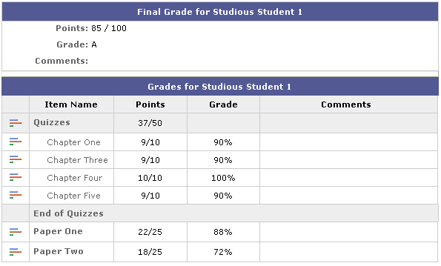

# Chat

***Chat***is accessible from the course home page by clicking the ***Chat*** link located on lower **Navbar** as shown in the Figure below.

http://ets.mnsu.edu/d2l/tutorials/images/Navbars_Chat.gif

Using the chat tool

1. Click ***Chat*** link located on the course Navigation Bar.
2. Click on the chat title you wish to enter from the available chat titles.
3. All the available participants are listed on the left side of the page
4. If you wish to send the messages type the message in the white box at the bottom of the box.
5. Click http://ets.mnsu.edu/d2l/tutorials/images/Chat_AddMsg.gif to send the message. The message you typed should be available on the upper box for everyone to view your message.
6. When you are done chatting, click http://ets.mnsu.edu/d2l/tutorials/images/Chat_ExitChat.gif.

Other Chat tools

|  |  |  |
| --- | --- | --- |
| Refresh: |  | You may refresh the chat window by clicking on the icon http://ets.mnsu.edu/d2l/tutorials/images/Chat_Refresh.gif. |
| Print: |  | If you would like to print the conversation by click the icon http://ets.mnsu.edu/d2l/tutorials/images/Chat_Print.gif. It will display the conversation in the printable form. |
| Change Chat User Identity: |  | If you would like to change your display name, font color and style then you may click the icon http://ets.mnsu.edu/d2l/tutorials/images/Chat_UserID.gif. It will display the pop up window. You can change the name, color and font style. After you are done setting click Submit, and click close. |

# Glossary

The **Glossary** works similar to the one that is usually found in the glossary section of textbooks. In the **Glossary** section you may find the definition of terms related to the course. The **Glossary** is accessible from the course home page by clicking the **Glossary** link located on the **Course Navbar**.

http://ets.mnsu.edu/d2l/tutorials/images/Navbars_glossary.gif

A popup window will be displayed with the definitions of keywords for the course. To exit glossary, click **Close Window** link.

