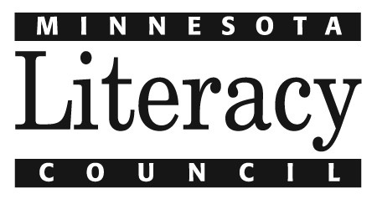

Program Assistant – Children’s and Family Department

Minnesota Literacy Council

Seeking a part-time program assistant to support the Children’s and Family Literacy Program Department. This position is 20 hours per week and supports Literacy VISTA, Summer Reads, Children’s Tutor Training and general Children’s and Family programming. The Program Assistant collaborates with the Children’s and Family Literacy Program Director, VISTA Program Manager, VISTA Program Coordinator, Senior Training Manager, Parent Mentoring Manager and other relevant staff on strategies relating to the work of the Children’s & Family department. This position is limited term through November 30, 2015 and subject to renewal based on funding.

Responsibilities for the Program Assistant include, but are not limited to:
- Assist with recruiting VISTA candidates, coordinating outreach opportunities and presenting to groups; posting positions, advertising through social media, scheduling phone screening, coordinating and conducting interviews, handling paperwork and conducting background checks.
- Research, contact and schedule meetings with potential site partners; participate as a team member during the VISTA site selection process and site visits.
- Assist with the planning for and management of orientations, trainings and in-service opportunities. Coordinate online training modules. Print, compile and assemble participant materials. Develop and maintain central training curriculum library.
- Create and send mass marketing emails, update website, schedule and research tutor training opportunities. Maintain training registration records.
- When possible, facilitate training workshops.
- Securing in-kind donations of supplies.
- As needed, assist in scheduling special events such as class field trips.
- Collaborate with Children’s and Family department team members to collect and compile data for reports.
- Assist book donation collection, processing and distribution.

Qualifications:
- Background in children’s literacy, volunteer management, National Service or education; experience as an AmeriCorps VISTA or AmeriCorps State/National, or experience working with National Service members.
- Bachelor’s degree in social justice, education, business or related field and 1-2 years of experience in an assistant role.
- Demonstrated success in efficiently performing administrative tasks in a collaborative team setting.
- Self-directed, ability to work well independently and with a diverse group of people.
- Excellent oral and written communication skills and strong organizational skills.
- Computer skills, including experience with MS Office software, email and internet.
- Familiarity with or interest in literacy and/or social causes.
- Grant writing and/or other writing experience desirable.

To apply email cover letter and resume with Program Assistant as the subject line to hr@mnliteracy.org by October 26, 2014.

The Minnesota Literacy Council is an affirmative action/equal opportunity employer. mnliteracy.org

