Temporary AmeriCorps VISTA Program Coordinator

Minnesota Literacy Council

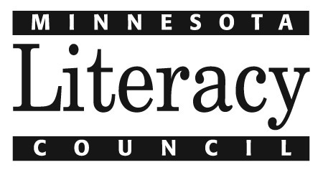

Seeking individual for full-time, temporary position to coordinate Summer Reads and Literacy VISTA programs. This position is 40 hours per week beginning the week of January 12, 2015 through May 22, 2015. The VISTA Program Coordinator is responsible for coordinating recruitment for Summer Reads and Literacy VISTA members. This includes conducting outreach, screening candidates, planning and scheduling candidate interviews and orientations, collecting and organizing candidates’ forms, and coordinating candidate placement. In addition, coordinate trainings, facilitate site selection, and assist host site supervisors in the Summer Reads program.

Specific responsibilities for the Temporary AmeriCorps VISTA Program Coordinator include, but are not limited to:
- Recruit potential Summer Reads and Literacy VISTA members in the Twin Cities and Greater Minnesota.
- Coordinate with Children’s Department Program Assistant to review applications, schedule and conduct candidate phone screening and interviews. Complete background checks; follow up on references and incomplete applications.
- Ensure that all applicant documentation is received and information is complete and accurate prior to member enrollment; approve applications in the online eGrants system; coordinate placement of members at host sites and finalize service schedules.
- Coordinate planning and scheduling of pre-service orientations and in-service training for members and host site supervisors.
- Conduct outreach to and collect applications from potential host sites, respond to questions, convene site selection committee and coordinate review of applications.
- Foster ongoing partnerships with Summer Reads host sites.
- Share progress with the Minnesota office of the Corporation for National and Community Service.
- Disseminate information and provide support to candidates, members and host sites.

Qualifications for this position include:
- Background in children’s literacy, volunteer management, human resources, working with young adults, and/or education strongly desired. Direct experience with National Service either as a member or working with national service members strongly preferred.
- Bachelors’ degree in social justice, education, business or related field and 1-2 years prior experience in a program coordination role required.
- Demonstrated success in event planning, marketing, recruitment or training.
- Self-directed, ability to work well independently and with a diverse group of people.
- Excellent oral and written communication skills.
- Excellent computer skills, including experience with MS Office software, email and internet.
- Familiarity with or interest in literacy and/or social causes.
- Superior organizational skills and ability to prioritize multiple tasks are essential.

To apply, please email cover letter and resume with “VISTA Program Coordinator” in the subject line to hr@mnliteracy.org by Friday, December 5, 2014.

The Minnesota Literacy Council is an affirmative action /equal opportunity employer. mnliteracy.org

