Introduction to Microsoft Windows

operating systems: XP and 7

Created for Adult Basic Education use. Contact Adult Basic Education Coordinator Cambridge-Isanti School District #911 625 Main Street North Cambridge, MN 55008. Phone: (763) 689-6228 Fax: (763) 689-6239 E-mail: vicki\_ostrom@cambridge.k12.mn.us

Table of Contents

[Basic skills 3](#_Toc332709911)

[Important Words 4](#_Toc332709912)

[Parts of the Windows desktop 5](#_Toc332709913)

[Desktop Icons and the Recycle Bin 7](#_Toc332709914)

[Exercise - Delete and restore an icon 7](#_Toc332709915)

[Exploring the Start button 8](#_Toc332709916)

[Exercise - Open Microsoft Word 9](#_Toc332709917)

[Explore the Control Panel 10](#_Toc332709918)

[Explore Documents or Libraries 11](#_Toc332709919)

[Software 12](#_Toc332709920)

[Parts of the Application Window 14](#_Toc332709921)

[Working with Windows 15](#_Toc332709922)

[Program Control buttons 15](#_Toc332709923)

[Minimize and maximize windows 16](#_Toc332709924)

[Resizing Windows 16](#_Toc332709925)

[Switch between windows 17](#_Toc332709926)

[Files and Folders 19](#_Toc332709927)

[Drives 19](#_Toc332709928)

[Exercise - Creating folders 20](#_Toc332709929)

[Exercise - Deleting and restoring folders 21](#_Toc332709930)

[Saving a document the first time 21](#_Toc332709931)

[File Names and File Types 23](#_Toc332709932)

[Help Menus 25](#_Toc332709933)

[Exercise – Changing settings 25](#_Toc332709934)

[Accessibility Options 27](#_Toc332709935)

[Ease of Access Center 27](#_Toc332709936)

[Assistive technologies 28](#_Toc332709937)

[Identifying the Operating System 29](#_Toc332709938)

[Windows XP and Windows 7 30](#_Toc332709939)

[Apple Mac OS X 32](#_Toc332709940)

[Ubuntu Linux 11 34](#_Toc332709941)

[Exercise – OS & RAM 36](#_Toc332709942)

[Computer Basics Review 37](#_Toc332709943)

# Basic skills

The Introduction to Microsoft Windows will help you learn these skills:

|  |
| --- |
| * Resize Windows |
| * Identify the taskbar |
| * Start and exit programs |
| * Define: Program  or Software |
| * Recognize drives on a computer: CD/DVD, floppy, hard drive (C), USB port, network drives |
| * Access the help menu |
| * Define and identify desktop |
| * Explain basic Windows file organization system and use it to locate files/documents, including desktop, My Documents and My Computer |
| * Use "Search" to locate a file or document |
| * Delete documents or files |
| * Understand trash/recycle bin and how to retrieve |
| * Identify basic office software programs such as Microsoft Word, Excel and PowerPoint, know what they do and be able to identify their corresponding file extensions |
| * Identify types of software: operating system, program/application, ‘Apps’ for phone & tablets |
| * Adjust volume or mute audio. Use headphones when appropriate |
| * Know that screen resolution can be changed |
| * Know that it is possible to customize a computer for increased accessibility |
| * Recognize various storage media including USB/flash drives (external) and hard drive (internal) |

# Important Words

|  |  |
| --- | --- |
| MS Clipart Hard Drive.png  Internal Computer Drive | Internal Computer Drive -  An internal computer drive is the thing that stores the software programs, and the files you save on your computer.    You cannot see an internal drive because it is inside of your computer. It is also called your local drive, or C Drive. You cannot easily remove the internal storage drive from your computer. |
| MS Clipart Hard Drive.png  External storage drive | External Storage Drive -  A large external drive gives you extra storage room for your large files like photos and video. It can also be used to make an extra copy of your files for security, but it is too big to carry with you. You leave it at your house.  External storage drives come in many different sizes and shapes. |
| IMG_3105-crop.jpg  USB Flash Drive | Flash Drive -  A flash drive is a small external storage device. A flash drive is portable. That means it is easy to carry with you. It is small enough to fit in your pocket. It plugs into a USB port on a computer. |
| Laptop-sm-no background2.jpg  USB Device | USB Device –  A USB device is any computer device that works with a computer when you plug it into a USB port on the computer. A mouse, a storage device, a printer or camera can all plug into a USB port. |
| Laptop-sm-no background2.jpg  USB Port | USB Port –  A USB device plugs into a USB port on the side or on the back of your computer. It only fits one way. If a USB device does not fit into your USB port, turn it over and try again. |
| Olivia Resume – Version 080811.docx  Olivia Resume – Version 082411.docx  File Versions | Version –  A version is another copy of something. To make a new version of a file on a computer, you just need to give it a new name and save it. |
| mousepad-black.jpg  Eject | Eject –  The word “eject” means to remove. It is best to always properly eject your flash drive befor you remove it from the USB port. |
| mousepad-black.jpg  Save As | Save As -  Clicking Save will write over your current file. If you click Save As from a computer menu, you can save your file with a new name, or to a new drive location, or in a different file format. |

# Parts of the Windows desktop

It is important to know the names of the parts of the Window so we can easily communicate instructions on how to use your computer. We will look at the two most common operating systems, Windows XP and Windows 7.

The *desktop* is what your computer screen looks like when you first start your computer. Just like a real desktop, it has folders, documents, and a calendar. Not all desktops will look the same. How your desktop looks depends on what software is installed on your computer and how the icons have been arranged on the desktop.

Why is it called Microsoft Windows? When you open a software program in Windows, that program opens in its own ‘window’ on your computer’s desktop.

**Windows XP desktop**

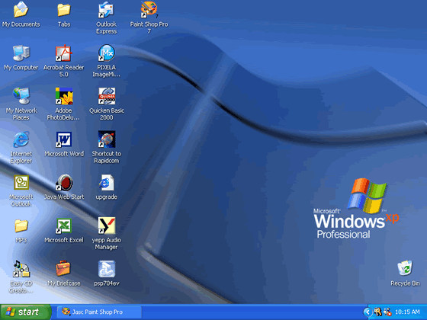

Icons

Task bar

(bar along the bottom)

Recycle Bin

Start button

**TIP: Windows XP vs. Windows 7**

*Windows 7 is a newer version of the Windows operating system. The desktop looks very much the same, but the start button in Windows 7 is a circle.*

Parts of the Windows desktop



2

4

1

3

**Match the name of the part of the Windows desktop to the number above:**

**Desktop \_\_\_**

**Start button \_\_\_\_**

**Task Bar \_\_\_\_\_**

**Desktop or shortcut icon \_\_\_\_**

## Desktop Icons and the Recycle Bin

The images on your desktop are called icons. If they have a small blue arrow in the left corner of the icon, they are a shortcut. That means it is a path to the actual file or application on your computer. The application or file is not actually on your desktop. You can create shortcuts to applications or files stored elsewhere on your computer. This allows you to easily access them with just a few clicks. Not all icons are shortcuts, but if you see the arrow, it is a shortcut.

The Recycle bin on the desktop is not a shortcut. It is where files and folders go if you delete them. If you delete something by mistake you can easily restore it (bring it back) because it is in the recycle bin.

## Exercise - Delete and restore an icon

To delete:

Right click on the icon, click delete. A ‘dialog box’ appears, asking if you are sure if you want to delete the shortcut. Click yes.

OR

Move your mouse over the icon, click and drag the icon to the recycle bin.

OR

Right click on the icon, click delete. A ‘dialog box’ appears, asking if you are sure if you want to delete the shortcut. Click yes.

Double click the recycle bin to open it. A window opens showing the contents of the recycle bin. You can restore items that are in the recycle bin. Restoring the item will return to its original place.

To restore:

Left click the item, choose Restore in the tool bar across the top. (A dialog box may appear asking you for permission, if the file is protected.)

OR

Right click on the icon, choose restore from the menu.

# Exploring the Start button

If you click on the Start button windows start.jpg, a menu appears like the ones below. (You can also open the start menu by clicking the key on your keyboard that has the start button icon.)

**Windows XP** **Windows 7**

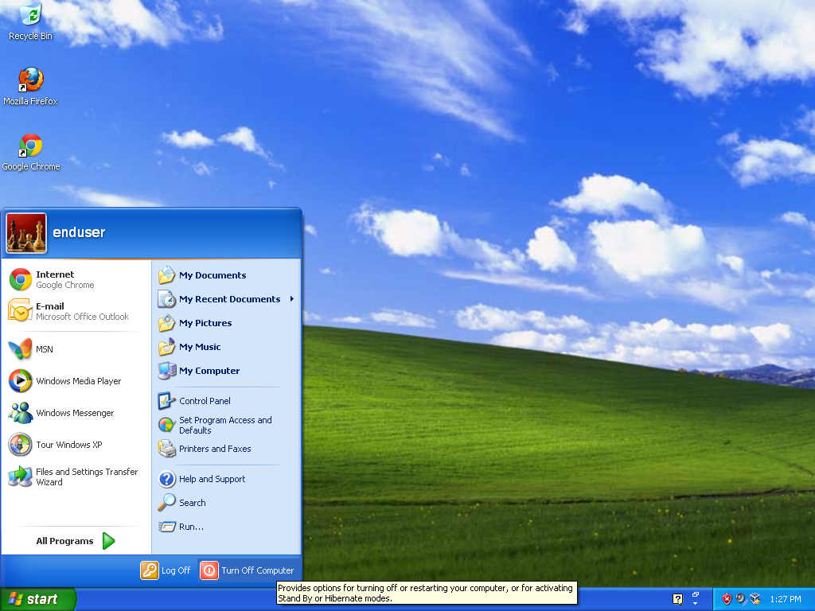 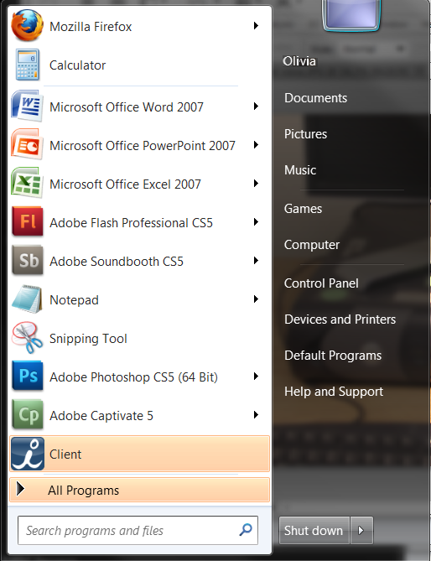

Let’s compare the Start button menus for Windows XP (the older version) and Windows 7. Let’s look at how they are organized. Windows XP and Windows 7 start menus are very much alike.

The Start button menu has three basic parts. This is where we **Shut down or log off**. **On the left** are programs that we have used recently. **On the right** is access is to commonly used folders, files, settings and other features.

The **user name** is listed across the top of the Windows XP menu. In Windows 7 the user name is listed at the top of the right column.

T**he left column** lists programs we have used recently. **Allprograms**, at the bottom left, lists *all* of the programs that are installed on your computer. These programs are listed alphabetically. Move your cursor over the name of a program and a small box displays information about the program. Notice that some of the programs are in folders. These are folders are listed after the individual programs. We need to open the folders by double clicking to see what’s inside.

**The right column** lists frequently used parts of the Windows operating system. **Documents** is where we store documents that we have created, **Pictures** holds pictures or photos, **Music** holds music and audio files, and **Games** holds games that we’ve installed or came with the operating system.

**My Computer** or **Computer** tells us about the disk drives and hardware that are connected to our computer.

**Control panel** This is where we can customize the appearance and functions of our computers, add and remove programs, set up networks and add users.

**Setting Program Access and Defaults or Default programs** allows us to tell the computer which programs we want to have immediately available.

**Help and Support** allows us to find information if we are having problems operating the computer.

**Search**, in the right column on Windows XP and at the bottom in Windows 7, allows us to search our computer when we are having trouble finding something on the computer.

Windows XP also has a separate selection called **Run** which is used when adding new software to your computer.

## Exercise - Open Microsoft Word

Sometimes there is a shortcut icon on the desktop that you can double click to open Word, but sometimes you need to find it. To open Microsoft Word:

Click Start, then All Programs

Click the Microsoft Office folder, then Microsoft Office Word.

## Explore the Control Panel

The Control Panel lets you change many of your computers settings, add new hardware, create user accounts, personal your desktop, and customize your computer for accessibility. Let’s look at a few of the options.

Hardware and Sound – Here you can add a printer, change your mouse settings, adjust the system volume, change your screen settings and more. Let’s try making a few common changes.

**Change the volume on your speakers or headphones:**

1. Click Start button
2. Click Control Panel
3. Click Hardware and Sound
4. Click Adjust system volume
5. Make adjustments by clicking and dragging

NOTE: Your headphones might also have a way to adjust the volume through a control located on the wires.

**Change the Display settings:**

1. Click Start button
2. Click Control Panel
3. Click Hardware and Sound
4. Click Display

Here you can choose to make it easier to read what’s on your screen by changing the size of the text and other items. Try making the display larger and see how it changes.

Notice that when the Control Panel window is open a menu appears along the left hand side. This allows you to easily move to other related settings that you might want to change without going back to the Start button.

**Adjust the screen resolution:**

The screen resolution refers to how sharp or in focus items appear on your screen.

1. Click Start button
2. Click Control Panel
3. Click Hardware and Sound
4. Click Adjust screen resolution

Your computer will offer some recommended settings.

## Explore Documents or Libraries

Click the start button and find My Documents or Documents in the right column.

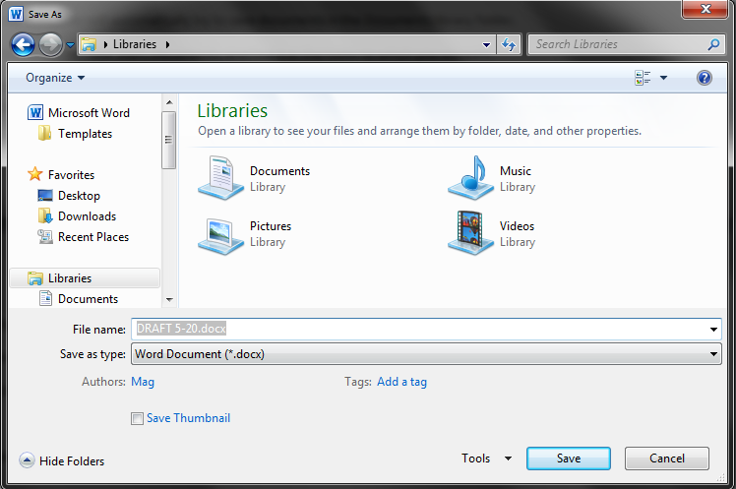Documents or Libraries are like filing cabinets you might have at work. The work that we want to store is called a file. These files are stored in folders that we create or that already exist, like Documents, Pictures, Music, and Videos.

Saving and organizing files

Your computer will automatically try to save documents in the Documents library folder.

To find a file that has already been saved, click Start, then Documents, and find it in the folder in which it was saved.

To organize your files, from the Documents or Libraries window, find New Folder at the tool bar across the top. Click New Folder, name the folder by typing in a new name.

To move files, you can cut and paste. Right click on the document, click Cut. Move to the folder you want to put it in, right click, click Paste. OR click and drag. When it says MOVE, release the left button.

Let’s explore the Documents or Libraries on your computer. Click the start button, find the Documents or Libraries folder on upper right hand side. Slide your mouse to the right and up to the folder. Click each folder. Is anything stored inside the Documents library? In the Music library? In the Picture library?

# Software

The terms *software*, *program,* and *application* refer to a set of instructions that tells the computer what to do. The most basic software or set of instructions is called the *operating system*. The Microsoft Windows operating system uses icons (little pictures) on the desktop that link to computer software programs, files and folders. If the icons don’t appear on the desktop, you can find the programs in the start button menu.

Some common types of software programs for your computer are:

|  |  |
| --- | --- |
| Operating system software | The most basic set of instructions for your computer. It tells your computer how to do what a computer should do, such as running other software, keeping things organized, etc. |
| Word processing software | Helps you write documents. Microsoft Word is the most common word processing program. |
| Virus protection software | Helps you keep your computer information safe.  Some free virus protection programs are Norton, McAfee and AVG. |
| Internet browser software | Helps you find information on the internet. Common browsers are: Internet Explorer, Firefox, Chrome, and Safari. |
| Email software | Helps you communicate with others and manages your email. Some common email programs are Gmail and Hotmail. |
| Spreadsheet software | Helps you track financial information. Microsoft Excel is the most common spreadsheet program. |
| Presentation software | Helps you present information to others. Like slide shows in the old days, presentations are often projected on screens to large groups of people. Microsoft PowerPoint and Prezi are two different presentation applications. |

There are also software programs for smartphones and tablets. These are different than desktop or personal computer applications. Applications, or ‘apps,’ for a tablet or smartphone.

|  |  |
| --- | --- |
| **Common software icons** | |
| https://encrypted-tbn3.google.com/images?q=tbn:ANd9GcRcGnhBIcxg3Wn7-iP0tudvHh4ZXYXpQH_JTIx2WLYK2SolOz-3 | Microsoft Word  A word processing application.  It helps you create documents like resumes and letters.  The file extension is .doc or .docx |
| https://encrypted-tbn1.google.com/images?q=tbn:ANd9GcSC-OfXmzzb5jSJVIjC5b0XI2ng-o2px7g___ucaoegRdahvC2ZLhMbtI9xQg | Microsoft Excel  A spreadsheet application.  It helps you save information in columns and rows  and is very good for working with numbers.  The file extension is .xcl or .xclx |
| https://encrypted-tbn2.google.com/images?q=tbn:ANd9GcQNE60rqkwKrBfemPekGnhoQsysvbcK-Jk5ebIeMR0IcxXr79wq | Microsoft PowerPoint  A presentation application.  It helps you create “slide shows” to make presentations.  The file extension is .ppt or .pptx |
| https://encrypted-tbn1.google.com/images?q=tbn:ANd9GcR98GPBihIVFgkW32vGGk7wQrQ1raONYgqBNOY6EUQvlZNG_FKJOA | Folder  Folders hold files, just like a real folders. |
| https://encrypted-tbn1.google.com/images?q=tbn:ANd9GcQCzdk2dEyLuti6rXL4ZlJzs5nnL9MJalxPy_RYaRatvl6FULRXdw | My Computer or Computer  This gives you access to  everything on your computer. |
| https://encrypted-tbn3.google.com/images?q=tbn:ANd9GcQ5DwXIGuzDp1xogETv2y-QYABt3P9Rzfs8B2NuCqN3KjjbuukB | Recycle Bin is where things go when you delete them.  If you right click on the bin,  you can permanently delete items in the recycle bin.  Or click restore to use the items again. |
| https://encrypted-tbn2.google.com/images?q=tbn:ANd9GcQJn6yj9L7oqk7CFOxtD6LrHIB85ntJdA4weang_rvKOrfQFiO4hQ https://encrypted-tbn2.google.com/images?q=tbn:ANd9GcRKydekm_pj8_FpmfpZd30BcWEPqVD-QJ6MuMGpA98yyVru217khttps://encrypted-tbn0.google.com/images?q=tbn:ANd9GcRVFnBusH4g9K8gVOytwkt_eFcOQQUi28WFYh83IW2wp7KEQGKChttps://encrypted-tbn2.google.com/images?q=tbn:ANd9GcSZ_a083-yeHvCVlpJDB6Z143O01WsIHFyyyQs85p8F0iQyE9foWw | You might find an internet browser on your desktop.  Popular browsers are Internet Explorer, Firefox,  Chrome, and Safari. |

You can start the programs by double clicking on the icon or right-clicking on the icon and selecting OPEN from the menu that appears. Microsoft Office is a suite or collection of software that typically includes Words, Excel, and PowerPoint among other applications. The newer versions of Office have an “x” at the end of the file name.

# Parts of the Application Window

Most Windows applications are arranged in a similar way. Below is an example of an Internet Explorer window that shows many of the common features:

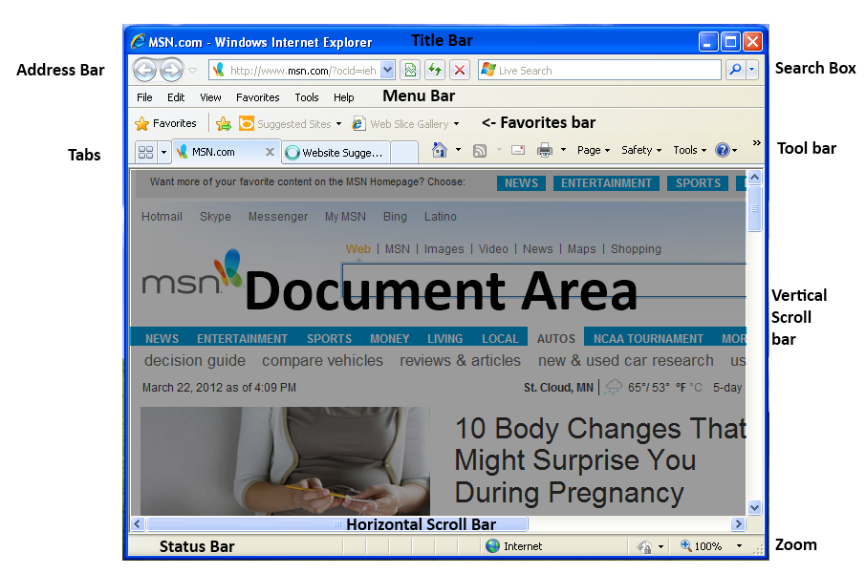

**Title bar** – Displays application name and name of current file.

**Menu bar** – This changes with each application but will typically contain: File, Edit, View, Tools and Help menus.

**Tabs** – Tabbed Browsing was first used in web browsers but is now gaining popularity in other applications. Tabs are a way to have multiple files open in a single application window.

**Ribbon or tool bars** – vary depending on application  
**Scroll bar** – side and maybe bottom

**Document** – in the middle large

**Status bar** – at bottom

# Working with Windows

You can open many Windows at one time. This is called multitasking. You can also run many programs at one time. For example, you can have your email open, find a page on the internet, and have a Word program all running at the same time.

Try opening the recycle bin. It opens a dialog window, asking you questions about what you want to do.

## Program Control buttons

The three buttons in the upper right corner of an application window are the Program Control buttons.

The button in the middle is the Maximize and Restore Down button.

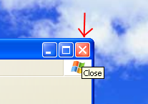

The red X on the right closes the Window.

Windows XP Windows 7

 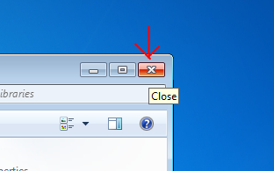

## Minimize and maximize windows

The button on the left looks like a minus sign. This is the Minimize button. Minimize does not close the window. It moves it to a tab or button on the task bar across the bottom of the window. To open it again, simply click on its button on the task bar.

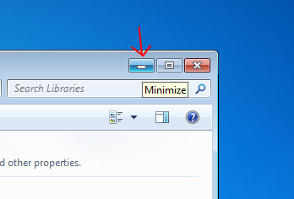

Maximize makes the window as large as possible with one click, and makes it slightly smaller if you click it again.

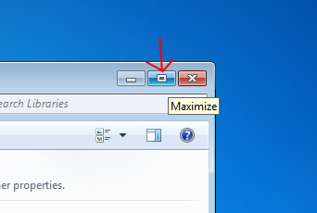

## Resizing Windows

When you bring the mouse pointer to the edge of a window it will change to one of the resize arrows. When the pointer changes to one of these arrows, you can click and drag to change the size of the window. The horizontal and vertical arrows will only resize it in one direction at a time. The diagonal arrows will change both the height and the width of the window.

## 

## Switch between windows

When you are multitasking (that is when you have two or more windows open), the window that appears in the front is the active window. There are a few different ways to switch the active or foreground window. If both windows can be seen at the same time click on the window that is partially covered to bring it to the foreground. If you can’t see the background window, find its title in the task bar and click on it.

Windows XP

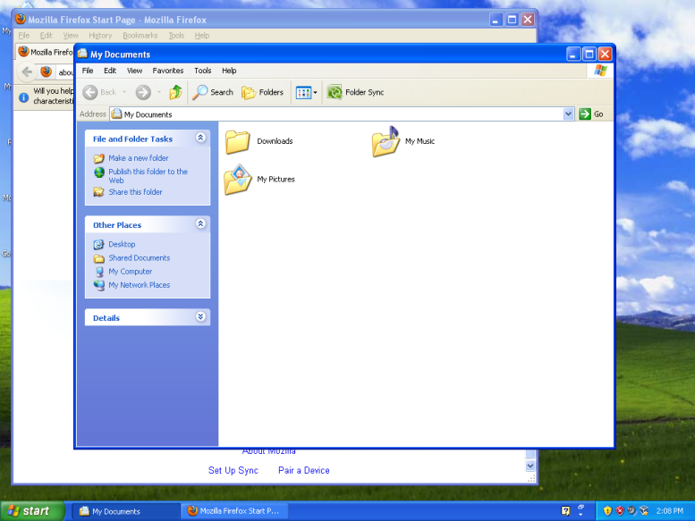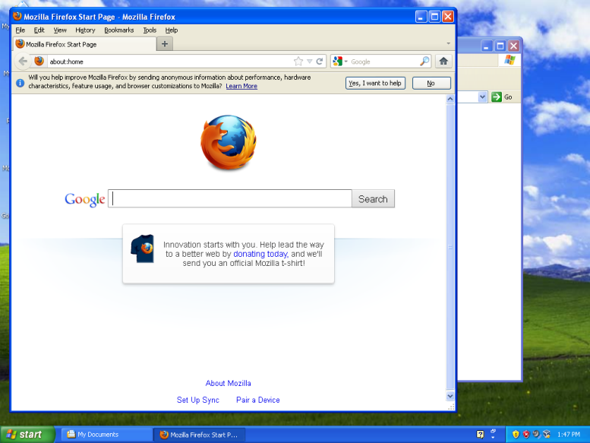

Windows 7

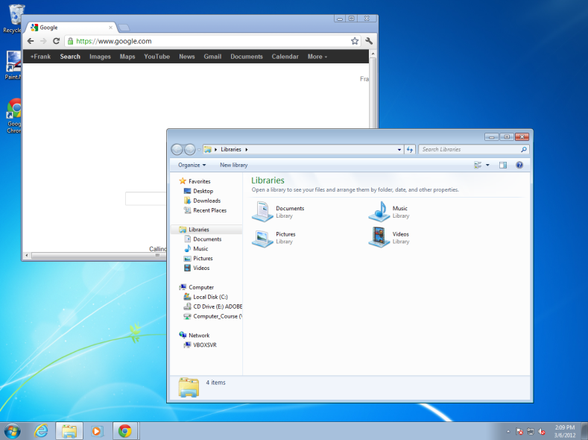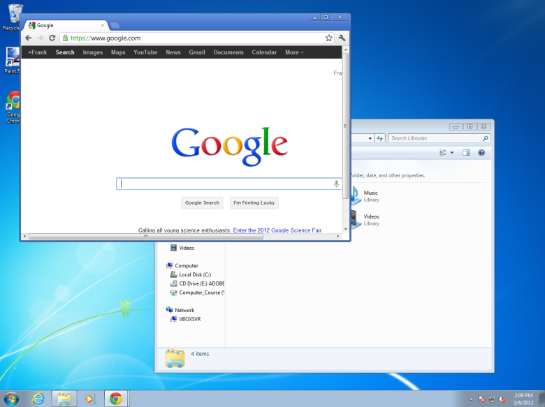

In Windows 7, when there are multiple windows open in the same program they will stack in the task bar to save space. Clicking on the program icon will show names or previews of the windows currently open.

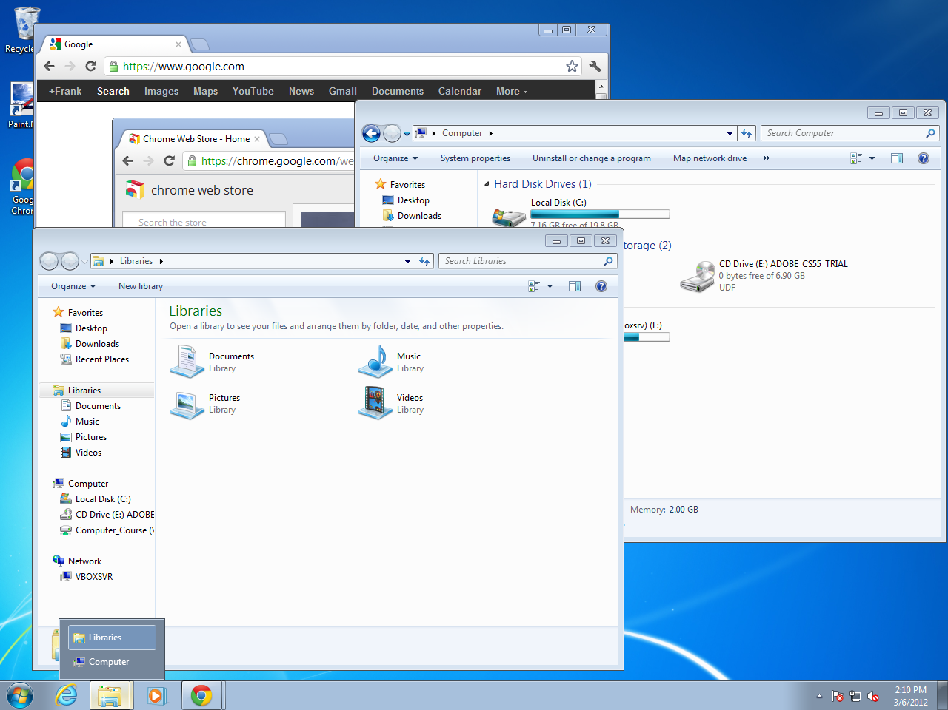

# Files and Folders

A file is a single document. The file might be a Word document, and Excel spreadsheet, or a PowerPoint presentation. When you double click the file icon, it will open the software that created it and the file itself. (Or you can right click and select OPEN to open the file.)

A folder is where you can save files to keep them organized. A folder icon looks like a folder that you might have in real life. When you open it, you will see a list of files stored in the folder. It can even store other folders.

## Drives

You can think of drives on your computer as filing cabinets used to store folders and files in different places.

The filing cabinets (or drives) are different sizes, and each one is named after a letter (A:, C:, D:, E:, H:) Inside of each filing cabinet are multiple folders with different names. Inside each folder are the actual files. All of the drives connected to your computer are listed in My Computer or Computer. Click the start button, then click My Computer or Computer in the right hand column. You will see the different drives or “filing cabinets” that are currently installed. Each filing cabinet (drive) has a letter and a name.

**Space in a computer is measured in Bytes.**

Bytes are very small. When we talk about space on our computer, we talk about thousands and millions of bytes:

1 Kilobyte (KB) = 1,000 Bytes

1 Megabyte (MB) = 1,000 KB

1 Gigabyte (GB) = 1,000 MB

**Sizes of common files**

• Word document (30 pages) =200 KB

• Image file (4”x6” for print) =6.2 MB

• PowerPoint (100 slides) =25 MB

• Sound file (3 minutes) =30 MB

• Image file (2’x3’ for print) =100 MB

**Local Disk (C:)** This is a hard drive that is built into the computer. You can only access it on this specific computer.

**3½ Floppy (A:)** Floppy disks work well to transfer small files (like Word) from one computer to another. However, they have very limited storage space and they fail over time. Floppy disks used to be very common. Some new computers no longer have floppy drives. Size: 1.4 MB

**CD-RW or DVD/CD-RW Drive (D:, E:, or F:)** DVDs hold 12 times the amount of bytes as a CD. To write (that is, to store information on a CD or DVD), the computer needs a CD-RW or DVD-RW drive. The RW stands for Read and Write. Some drives will only Read the information but can’t Write new information on the CD or DVD. CDs and DVDs can scratch and lose data over time. Size: CD: 650/700 MB, DVD: 4.7/8.5 GB (dual)

**USB/Flash Drive (D:, E:, or F:)** Flash drives are small portable devices that plug into the USB port on a computer. Some computers also have built in flash memory card reads that can read cards from phones or cameras. Newer ones work very fast, but older ones can be quite slow. Many sizes are available and they are very stable (that is, they won’t break as frequently as other drives) because they have no moving parts. Size: 2MB to 128GB

## Exercise - Creating folders

Saving, deleting, and restoring files are some most important computer skills. After all, you want to be able to find your files! It will take some practice. Do these steps many times until you are comfortable saving, deleting, and restoring files.

To create a folder with your name on the desktop:

Right click – select New – select Folder

OR

Click the Start button, then Computer, click Desktop from the list of locations on the left, then find New Folder in the toolbar across the top

Highlight the name New Folder and type your name

To create a folder on a jump drive

Attach the jump drive to your computer

Click the Start button, then Computer

Locate the jump drive from the list on the left (it is typically listed as Removable Disk or the brand name of the jump drive)

Click New Folder in the toolbar across the top

Highlight the name New Folder and type your name

## Exercise - Deleting and restoring folders

To delete a folder:

Locate the folder you want to delete (go to Start Button – My Computer….)

Right click on the folder, then Delete

OR

Locate the folder you want to delete (go to Start Button – My Computer….)

Click and drag the folder to the Recycle Bin

To restore a folder:

Double click the recycle bin to open

Locate the folder you want to restore

Right click, then click Restore

The folder will return to its original location

Saving files:

## C:\Users\enduser\Documents\Computer Course\XP\ofice button.pngSaving a document the first time

**In Office 2007**

1. Click the Microsoft Office Button
2. **Click Save As.**
3. **A Save As dialogue box will appear.**

**In Office 2010**

1. **Click the File tab**   **This opens what is called the Backstage View.**
2. **Click Save As.**
3. **A Save As dialogue box will appear.**

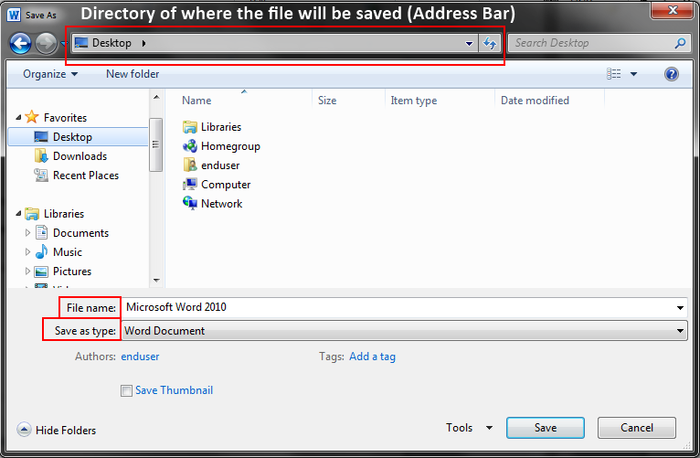

**There are three things you should look at when saving a document: where you are saving the document, the name of the document, and the file type.**

1. Navigate **to the directory where you want to save your document.**
2. Name **your document.**

**The file type will automatically be the version of Word in which you created your document.**

## File Names and File Types

**What is a file name extension?**

A file name extension is a set of characters that helps the Windows operating system understand what kind of information is in a file and what program should open it. It is called an extension because it appears at the end of the file name, following a period. In the file name myfile.doc, the extension is doc. It tells Windows that this is a document file that can be opened by programs associated with that extension, such as Microsoft Word.

**How can I control which programs are associated with a file name extension?**

Every program that's installed on your computer is designed to open one or more particular file types, each of which is identified by a file name extension. If you have more than one program on your computer capable of opening a file type, then one program is set as the default or preset program to open that type of file.

**How to change the program that opens a type of file:**

If you double-click a file in Windows and it opens in the wrong software program, follow these steps to choose the program you would prefer that file use. You can change this setting for an individual file, or you can tell Windows to open all files of that same type in the software program you choose.

1. Open the folder that contains the file you want to change.
2. Right-click the file that you want to change, and then, depending on the type of file, either click **Open With** or point to **Open With** and then click **Choose Default Program**.
3. Click the program that you want to use to open this file.
4. Do one of the following:
   * If you want all files of that type to open in the same software program, select the **Always use the selected program to open this kind of file** check box, and then click **OK**.
   * If you want only that file to open in the software program this one time, clear the **Always use the selected program to open this kind of file** check box, and then click **OK**.

**What is the maximum length of a file name?**

Windows usually limits file names to 260 characters. But the file name must actually be shorter than that, since the complete path (such as C:\Program Files\filename.txt) is included in this character count. This is why you might occasionally encounter an error when copying a file with a very long file name.

**Which characters can't be used in a file name?**

You can't use any of the following characters in a file name: \ / ? : \* " > < |

**How can I see file name extensions in the file name?**

By default, Windows hides file name extensions to make file names easier to read, but you can choose to see the file extensions.

**To change the program that opens a type of file**

If you double-click a file in Windows and it opens in the wrong software program, follow these steps to choose the program you would prefer that file use. You can change this setting for an individual file, or you can tell Windows to open all files of that same type in the software program you choose.

1. Open the folder that contains the file you want to change.
2. Right-click the file that you want to change, and then, depending on the type of file, either click **Open With** or point to **Open With** and then click **Choose Default Program**.
3. Click the program that you want to use to open this file.
4. Do one of the following:
   * If you want all files of that type to open in the same software program, select the **Always use the selected program to open this kind of file** check box, and then click **OK**.
   * If you want only that file to open in the software program this one time, clear the **Always use the selected program to open this kind of file** check box, and then click **OK**.

**How do I change a file name extension?**

Usually, file name extensions should not be changed because you might not be able to open or edit the file after doing so. Sometimes, however, changing the file name extension can be useful—such as when you need to change a text file (.txt) to an HTML file (.htm) so that you can view it in a web browser. To change a file name extension, first ensure that file name extensions are visible. Then, right-click the file you want to change and click Rename. Delete the file name extension, type the new extension, and then press ENTER. Windows will warn you that changing the file name extension might cause the file to stop working properly. If you are certain that the extension you typed is one that the program you are using will understand, click Yes to confirm the change.

# Help Menus

Many programs come with the instruction manual integrated into the program.

If you encounter a problem or forget a command while running a program, you can summon help by pressing a designated Help key (usually F1). In fact, on many keyboards, the F1 key will be labeled F1 HELP.

Virtually all well-designed programs will have a Help Menu located on the program’s Menu Bar. (It may be in the form of a white question mark on a blue circular background tucked on the right side of the menu bar.) Once you summon the Help system, the program often displays a menu of Help topics. You can choose the appropriate topic for whatever problem you are currently encountering.

The program will then display a help screen that contains the desired documentation.

If you are seeking help with regard to your Windows operating system, or one of the programs that is directly connected to the operating system (examples: WordPad, Internet Explorer, and Outlook Express (XP), Windows Mail (Vista) or Windows Live Mail (Windows 7), the best and fastest way to access the Windows

HELP AND SUPPORT menu is via the Start button, located on the left side of your taskbar.

The HELP AND SUPPORT button is a comprehensive resource for practical advice, tutorials, and demonstrations to help you learn to use your Windows operating system.

## Exercise – Changing settings

All software – including the operating system – comes with default or pre-set settings. You can change these settings if it doesn’t work the way you want it to. Let’s say when you are typing you often get repeated characters, as if you are holding the key down. You can change the keyboard settings, but you might not know where or how. You can use Help and Support: the Search Option in **Windows 7** to find the information you need.

1. Click on the START button.

2. Click on the HELP AND SUPPORT button.

3. Click on the SEARCH HELP box (at the top of the window) and type the word KEYBOARD.

4. Press the ENTER key on the keyboard.

5. The search will yield thirty (30) results.

6. Scroll down and click on CHANGE KEYBOARD SETTINGS.

7. Click the option TO CHANGE THE DELAY BEFORE KEYBOARD CHARACTERS

REPEAT.

8. Click the option CLICK TO OPEN KEYBOARD PROPERTIES

9. Under CHARACTER REPEAT, move the two REPEAT DELAY and REPEAT

RATE sliders to the left or right to change the amount of time you must hold down a key before that keyboard character repeats. Use the test box to verify your new setting.

10. Note also that you can change the CURSOR BLINK RATE while in this dialogue box.

11. When you are satisfied, click OK.

12. Click on the X box in the upper right corner of the window, then click the X box on the other open window to get back to your desktop.

Help and Support: Search Option in **Windows XP**

1. Click the Start button

2. Click on the Help and Support button.

3. A two-column Table of Contents will appear.

4. A Search box will appear near the upper left corner of the window.

5. Type the word keyboard in the search box and press <Enter> on the keyboard.

6. The search will yield fifteen (15) Suggested Topics which appear in the left column.

7. Click on Adjust key repeat rate.

8. Follow the steps listed in the right column, namely:

9. Go to the Start Button and click on Control Panel in the right column.

10. On the Speed tab, make changes as follows:

a. To adjust the amount of time that elapses before characters repeat when you hold down a key, drag the Repeat delay slider.

b. To adjust how quickly characters repeat when you hold down a key, drag the Repeat rate slider.

c. Use the test box to check your new settings, then click OK.

Now close all windows to get back to the desktop.

# Accessibility Options

Windows offers several programs and settings that can make the computer easier and more comfortable to use. Additional assistive technology products can be added to your computer if you need other accessibility features.

## Ease of Access Center

The Ease of Access Center is a central location that you can use to set up the accessibility settings and programs available in Windows. In the Ease of Access Center, you'll find quick access for setting up the accessibility settings and programs included in Windows. You'll also find a link to a questionnaire that Windows can use to help suggest settings that you might find useful.

Open Ease of Access Center by clicking the **Start** button Picture of the Start button, clicking **Control Panel**, clicking **Ease of Access**, and then clicking **Ease of Access Center**.

**Use the computer without a display.** Windows comes with a basic screen reader called Narrator that will read aloud text that appears on the screen. Windows also has settings for providing audio descriptions for videos and controlling how dialog boxes appear. Additionally, many other programs and hardware are compatible with Windows and available to help individuals who are blind, including screen readers, Braille output devices, and other useful products.

**Make the computer easier to see.** Several settings are available to help make the information on the screen easier to see. For example, the display can be magnified, colors can be adjusted to make the screen easier to see and read, and unnecessary animations and background images can be removed.

**Use the computer without a mouse or keyboard.** Windows includes an on-screen keyboard that you can use to type. You can also use Speech Recognition to control your computer with voice commands, and dictate text into programs.

**Make the mouse easier to use.** You can change the size and color of the mouse pointer, and use the keyboard to control the mouse.

**Make the keyboard easier to use.** You can adjust the way Windows responds to mouse or keyboard input so that key combinations are easier to press, typing is easier, and inadvertent key presses are ignored.

**Use text and visual alternatives for sounds.** Windows can replace two types of audio information with visual equivalents. You can replace system sounds with visual alerts and you can display text captions for spoken dialog in multimedia programs.

**Make it easier to focus on reading and typing tasks.** A number of settings can help make it easier to focus on reading and typing. You can have Narrator read information on the screen, adjust how the keyboard responds to certain keystrokes, and control whether certain visual elements are displayed.

## Assistive technologies

In addition to the Ease of Access Center, Windows includes three programs that can make it easier to interact with your computer.

* **Magnifier.** Magnifier is a program that magnifies a portion of your computer screen, making it easier to read. For more information about using Magnifier, see Make items on the screen appear bigger (Magnifier).
* **Narrator.** Narrator is a program that reads the text on your screen aloud. For more information about using Narrator, see Hear text read aloud with Narrator.
* **On-Screen Keyboard.** On-Screen Keyboard is a program that lets you use your mouse or other device to interact with a keyboard on the screen. For more information about using On-Screen Keyboard, see Type without using the keyboard (On-Screen Keyboard).

# Identifying the Operating System

The most basic software or set of computer instructions is called the *operating system*. The operating system manages or operates your computer put hardware in a way that allows you to interact with it. It is used to start software programs, and manage files, memory, and hardware. It is different from program or application software, which is designed to do specific jobs.

Microsoft Windows is the most common operating system software, but is not the only operating system. Also, there are different versions of the Windows operating system. A very common older version is called Windows XP. A newer version is Windows Vista. The newest version is Windows 7.

There are different kinds of operating systems available for different types of computers: Microsoft Windows (XP & 7), Apple Mac OS X, and Ubuntu Linux. The majority of desktop and laptop computers run either a version of Microsoft Windows or Apple’s Mac OS. There are also mobile operating systems available for smartphones and tablets (Apple’s iOS and Google’s Android are the most popular. There are differences between these operating systems, but also many similarities.

You may need to identify the operating system of a computer if you are having trouble or if you are purchasing new software.

## Windows XP and Windows 7

1. Right-Click on the My Computer or Computer Icon on the Desktop.
2. Select Properties.
3. Under System, you will see the technical specifications and type of operating system on your computer.

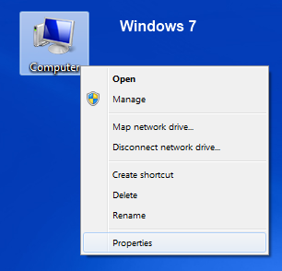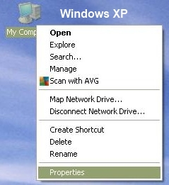

If you are unable to locate the icon on the Desktop you can also find it in the start menu on computers running Windows:

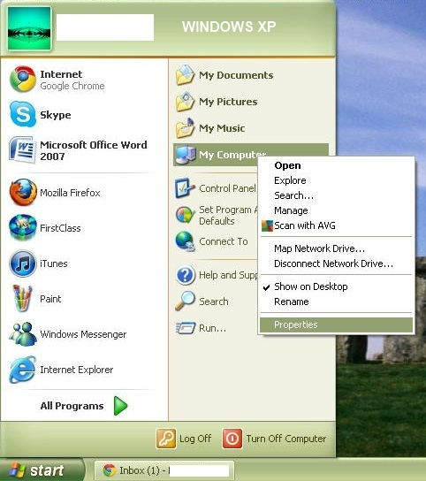 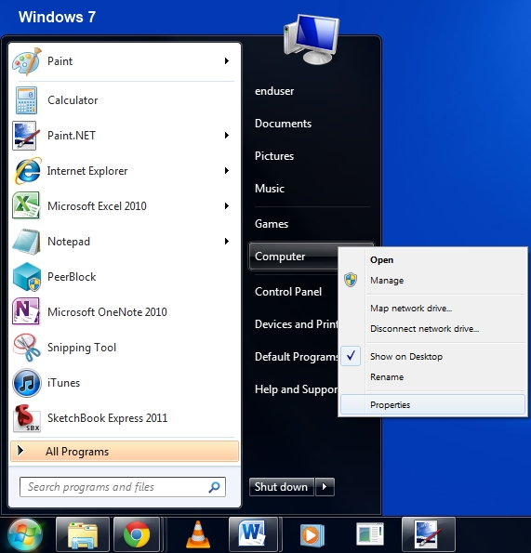

This will bring up the system control panel which displays basic information about the computer you are using such as operating system version, processor type and speed and the amount of memory (RAM) that is installed.

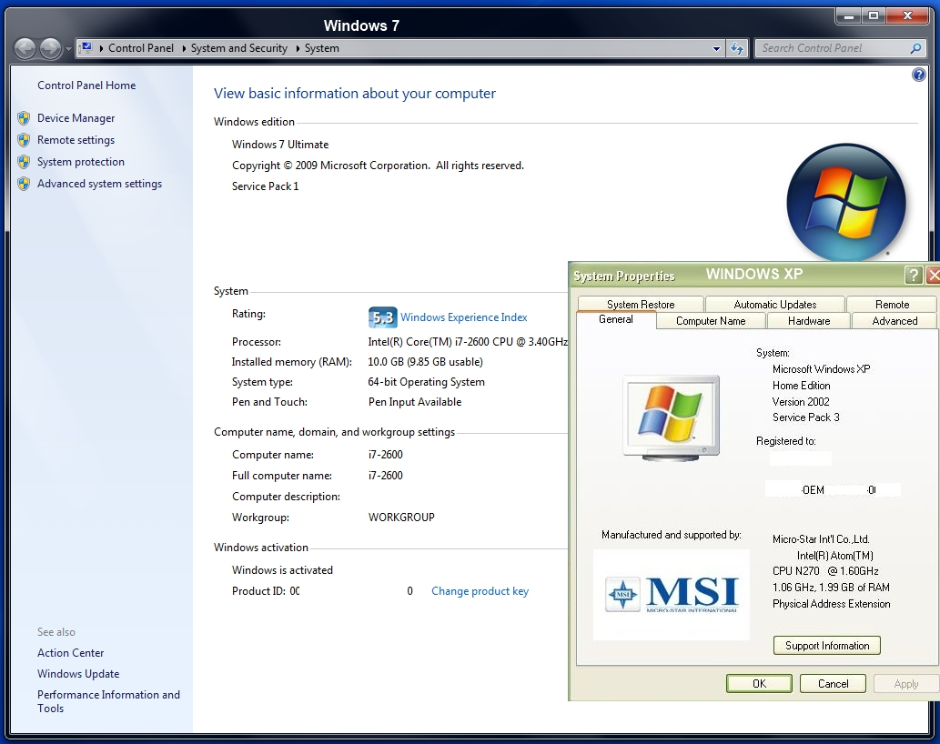

If there isn’t a computer icon on the Desktop and you can’t find the start menu it is possible your computer is running an operating system other than Windows.

## Apple Mac OS X

Apple, Inc. (formerly Apple Computers) makes Macintosh computers, the iPhone and iPad and runs the online service iTunes. Their Macintosh computers (or Macs) run an operating system called MacOS. They are popular with artists and people in the entertainment industry because of their clean design and ease of use. Here is how to find out what version of MacOS is running.

Click the apple icon in the upper left hand corner. Click it and select the first item ‘About This Mac’

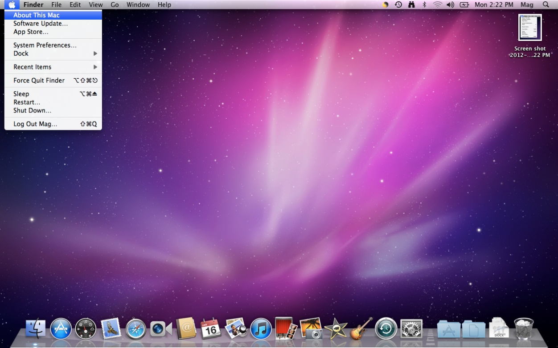

This should bring up a dialogue with the basic information about the computer as well as links to software updates and more detailed hardware information.

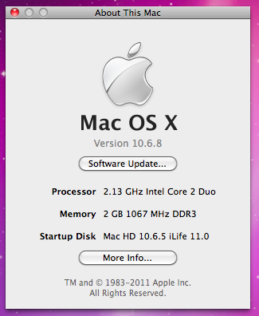

The majority of desktop and laptop computers run either a version of Microsoft Windows or Apple’s Mac OS. If you are unable to determine what operating system you are using by one of the above methods you may be on a computer that is running a version of the free, open-source operating system Linux.

## Ubuntu Linux 11

Linux is highly customizable so there is no universal way to determine the version. Watching the screens as the computer starts up should usually give you some indication of the operating system that is installed. Here is an example using the popular Ubuntu distribution of Linux.

Look for the gear symbol in the upper right corner of the screen next to the clock.

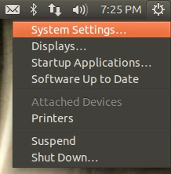

Click on it and select ‘System Settings’. This will open a control panel window.

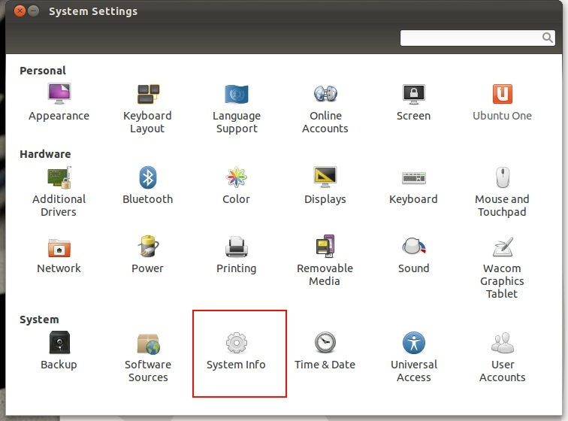

Then click on the ‘System Info’ icon.

Now the basic system information should be displayed.

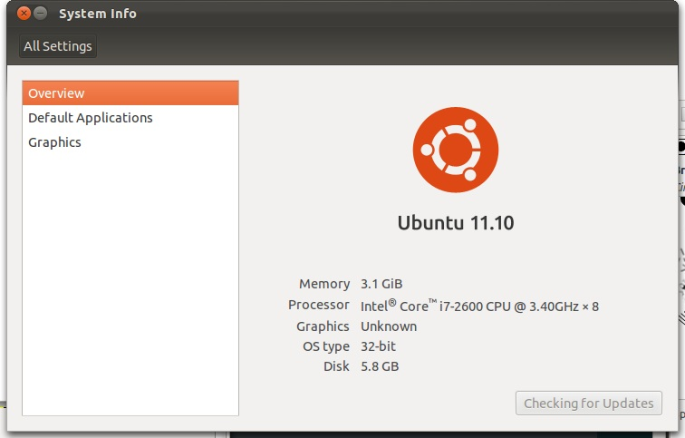

Microsoft Windows, Apple MacOs and Ubuntu Linux are the most common operating systems used on desktop computers. However computers have become ubiquitous and you probably carry one around with you every day.

 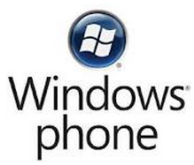

As technology has gotten better the line between a cell phone and a computer has gotten blurred. Smart phones or super phones are becoming increasingly common. And tablets have started to catch on as well thanks to Apple’s success with the iPad. The most common operating systems for these mobile devices are Apple’s iOS, Google’s Android Open Source Project (AOSP) and Windows Phone. There are many different versions of these operating systems in use and they are often customized by the hardware manufacturer to suit a particular device.

## Exercise – OS & RAM

Find the operating system type for your computer

How much ram? What is the processor speed?

Computer Basics Review

1. Is a desktop computer hardware or software?
2. Is an Internet browser hardware or software?
3. Is an Operating System hardware or software?
4. Is a monitor hardware or software?
5. Is a spreadsheet application hardware or software?
6. Is a word processor software or hardware?
7. Is a flash drive software or hardware?
8. Is a mouse hardware or software?
9. Is it safe to turn off your computer by pressing the power button?
10. Is turning on your computer the same as logging onto your computer?
11. How is a desktop computer different than the computer desktop?

|  |  |  |  |
| --- | --- | --- | --- |
| BASIC COMPUTER SKILLS | Not yet | With assistance | Independently |
| Resize Windows |  |  |  |
| Print and use print preview for documents |  |  |  |
| Identify the taskbar |  |  |  |
| Start and exit programs |  |  |  |
| Define: Program  or Software |  |  |  |
| Recognize drives on a computer: CD/DVD, floppy, hard drive (C), USB port, network drives |  |  |  |
| Access the help menu |  |  |  |
| Define and identify desktop |  |  |  |
| Explain basic Windows file organization system and use it to locate files/documents, including desktop, My Documents and My Computer |  |  |  |
| Use "Search" to locate a file or document |  |  |  |
| Delete documents or files |  |  |  |
| Understand trash/recycle bin and how to retrieve |  |  |  |
| Identify basic office software programs such as Microsoft Word, Excel and PowerPoint, know what they do and be able to identify their corresponding file extensions |  |  |  |
| Open files using appropriate programs |  |  |  |
| Identify types of software: operating system, program/application, ‘Apps’ for phone & tablets |  |  |  |
| Adjust volume or mute audio. Use headphones when appropriate |  |  |  |
| Know that screen resolution can be changed |  |  |  |
| Know that software programs are upgraded periodically and that different versions may be installed on different computers |  |  |  |
| Know that it is possible to customize a computer for increased accessibility |  |  |  |
| Recognize various storage media including USB/flash drives (external) and hard drive (internal) |  |  |  |